Part F: Statistical Quality Control — ANOVA Applications in Strength Reporting

By: Cleric Josh C. Najarro
Part F1: Define Groups
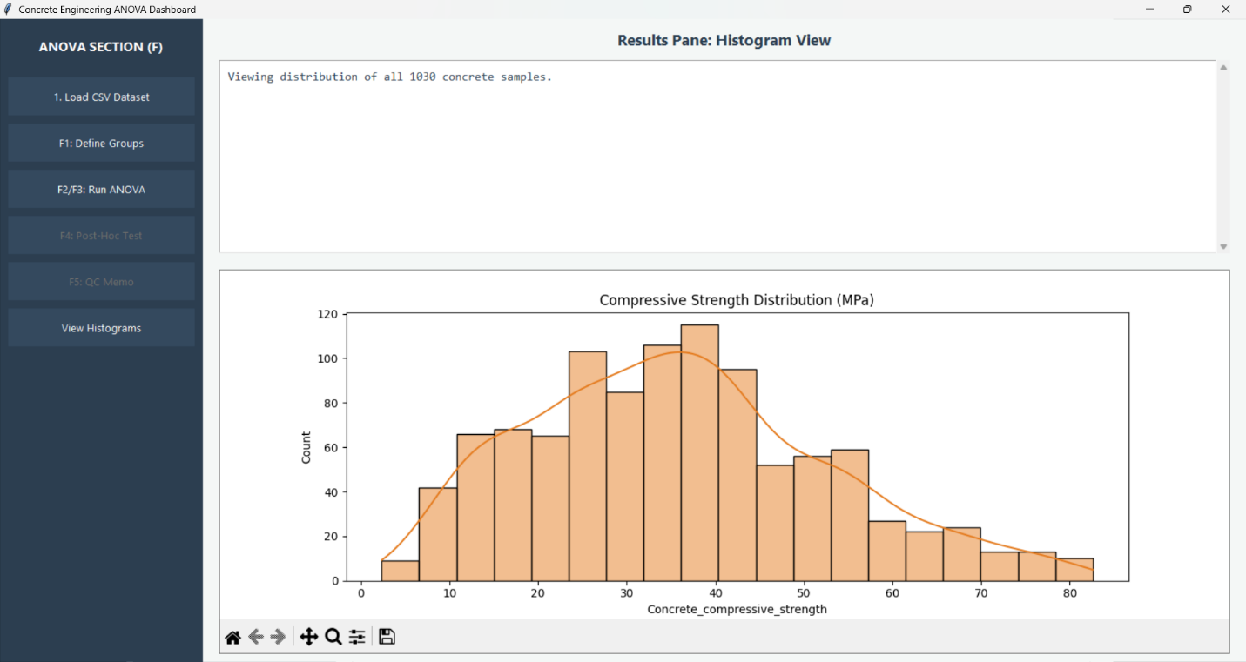
Part F2/F3: Run Anova
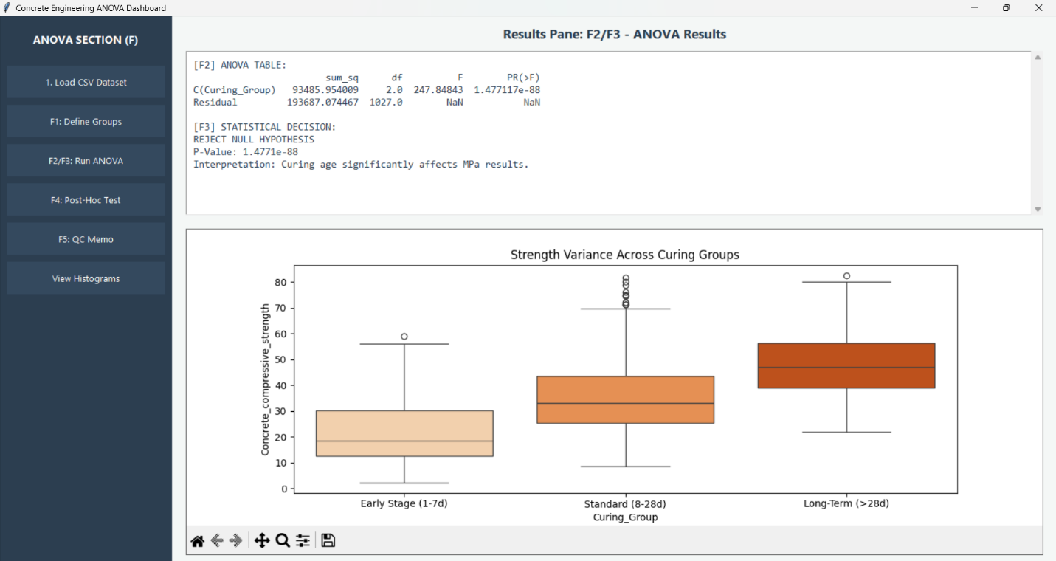
Part F4: Post-Hoc test
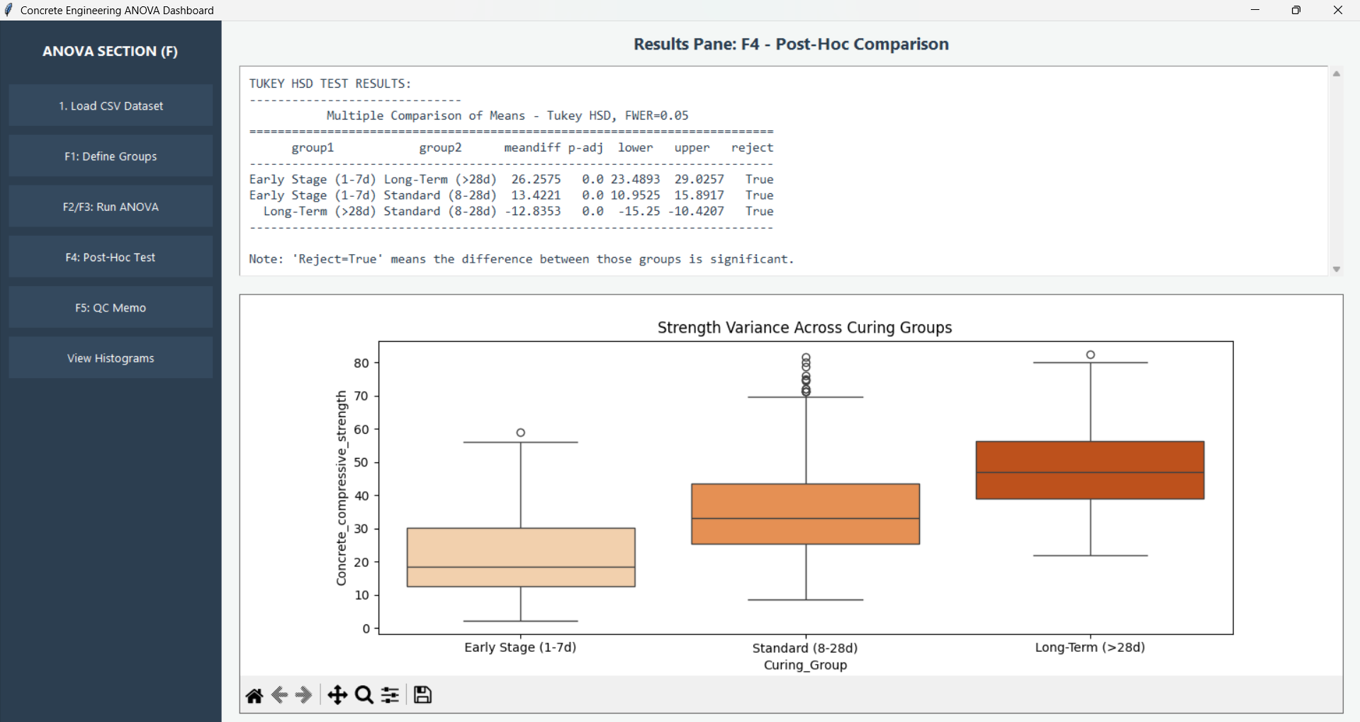

Part F5: Quality Control Memo
